Notes on Electromagnets
The magnetic field around a straight wire is not very strong.
A strong field can be made by coiling the wire around a piece of soft iron.
This electromagnet is sometimes called a solenoid. The shape of the magnetic field is the same as a bar magnet.
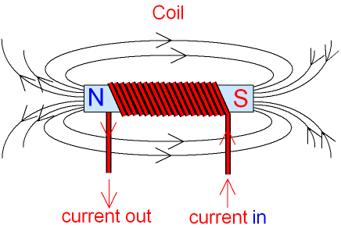
The soft iron inside the coil makes the magnetic field stronger because it becomes a magnet itself when the current is flowing. Soft iron is used because it loses its magnetism as soon as the current stops flowing.
Soft iron is said to form a temporary magnet. In this way, the electromagnet can be switched on and off by turning the electricity on and off.
Steel forms a permanent magnet. If steel was used inside the coil, it would continue
as a magnet after the electricity was switched off. It would not be useful as an electromagnet. Permanent magnets are needed for
electric motors, generators, loudspeakers and microphones.
The strength of the magnetic field around the coil can be increased by
1. Using a soft iron core (core means middle bit).
2. Using more turns of wire on the coil.
3. Using a bigger current.
Reversing the direction of the current will reverse the magnetic field direction. produces a constantly changing magnetic field.
An electromagnet is used in the electric bell, relay,
circuit breaker, loudspeaker and microphone.

