Kenton College Preparatory School
Science
Revision Pack
Michaelmas Term

In this pack you will find:

- Information on how to revise for this subject
- Information on what to revise
- Activities or information to help
- Websites that can help you

If you are accessing this from the Kenton Website, please note some aspects of the pack we cannot make public due to copyright reasons

The Exam – Year 6
- Your exam will be 60 minutes long
- There will be a range of questions on the topics that you covered between Lent exams and the Trinity exams.
Topics to be revised  - Acids & Bases  - Heart, lungs and breathing  - Respiration  - Health – fitness, drugs, smoking , bacteria and viruses  - Classifying Organisms  - Variation and Evolution  - Drawing graphs  - **Selective Breeding  - **Microscopes  - **Cells  - **Density  ** to be covered between now and the exams | 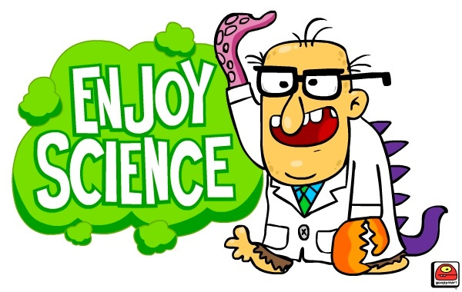
How to revise
- Read through your exercise books and make notes/mind-maps/flash cards on the most important points. Do not just read – this will not help you remember.
- Use the textbook you have to go over any areas you find difficult. You can use the pages with questions on to test yourself
- Use some of the websites below to help you learn and take quizzes to test yourself
- First pick out any topics that you are a bit unclear on and start with trying to understand these before you revise other things.
Supporting Activities included
- Download or print off the Year 6 Science lesson notes from the Science page under Curriculum/Senior Department of the Kenton website. These notes are also on the bioteacher website (below).
- Download or print the lesson slides to go over what we have done again or to catch up on anything you missed at: www.bioteacher.weebly.com (Under Common Entrance, Year 6 – scroll to the bottom of the page for this term’s lessons.
Helpful Websites
www.bbc.co.uk/bitesize/ks3/science - A good site for revising and testing yourself on specific topics
www.sciencenewsforkids.org
www.pitara.com/discover/5wh.asp
www.howstuffworks.com (Science section)
http://kids.nationalgeographic.com/kids/activities/funscience -A lot of fun ideas for experiments that can be done at home
www.kidsites.com/sites-edu/science.htm
http://kids/discovery.com/tell-me

